# Project Research Document

# FIFA 19 Team Builder

X00132028 – Alex Grant

## Section 1 Detailed Discussion

My project is based on a PlayStation and Xbox console game FIFA this game has a new release each year and it is only in the last few years FIFA has added FIFA Ultimate team. This is a section in the game that you can build your own team with players from the same league or nation. to create a squad (soccer) of players; the team can have a minimum of 16 players (eleven players for the starting line-up and five substitutes) or a maximum of 21 players (five reserve players). Since this has been introduced to the consoles, I have not seen a team generator to generate a team with the best overall status. I plan to have my app to be able to create a team that you would like, using drag and drop to create your team. In a different section I plan to have a drop-down menu to select a nation or a league and it will then auto-generate a team based on the selected input by the user.

There will four positions Goalkeeper (GK), Defender (LB, LWB, CB, RWB, RB), Midfielder (LM, LW, CDM, CM, RM, RW), Attacker (CF, ST) further broken up into specific positions in the for position mentioned. There are 29 attributes that make up the overall stat of each player, I will use 14 out of these attributes of my choice that I believe is relevant for each of the positions listed. I plan to use a calculation on each one of the attributes such as an extra .25 to the attribute that I feel is more valuable than others. Each attribute is between 0 – 100 on the consoles so to make it unique I will add extra marks on each of the 14 attributes that I have chosen to create my own algorithm

For the auto generation of a team.

The data I have is in an excel file that I got off Kaggle it has 16,555 players from each country and each league the dataset consists of gold, silver and bronze with some rare the rare players are selected players that are better than the normal gold, silver and bronze players. There are also icons these icon players are players that are retired and have been specially picked by FIFA because the had such a good career with their club and country I will also have an icon team to generate.

**Attributes**

|  |  |  |  |  |  |  |  |  |  |
| --- | --- | --- | --- | --- | --- | --- | --- | --- | --- |
| Pace | Shooting | Passing | Dribbling | Defending | Physicality | Goalkeeper | Preferred foot | Attacking work rate | Defending work rate |
| Acceleration | Positioning | Vision | Agility | Interceptions | Jumping | Diving | Left | Low | Low |
| Sprint speed | Finishing | Crossing | Balance | Heading | Stamina | Reflexes | Right | Medium | Medium |
|  | Shot power | Pass free kick | Reactions | Marking | Strength | Handling |  | High | High |
|  | Long shots | Short | Ball control | Stand tackle | Aggression | Speed |  |  |  |
|  | Volleys | Long | Dribbling | Slide tackle |  | Kicking |  |  |  |
|  | Penalties | Curve | Composure |  |  | Positioning |  |  |  |

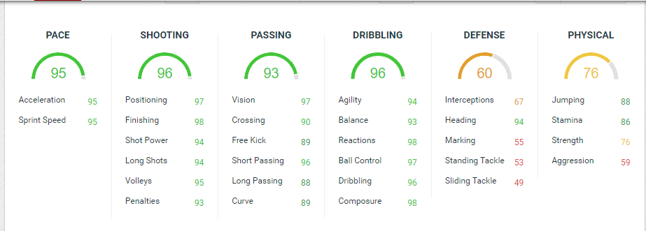

FIFA 19 Forum

<https://fifaforums.easports.com/en/discussion/428085/how-fifa19-stats-calculation-for-4th-year-project/p1>

**Team Types**

|  |  |  |  |  |  |  |
| --- | --- | --- | --- | --- | --- | --- |
| National | Bronze | Bronze – rare | Silver | Silver – rare | Gold | Gold – rare |
| Club | Bronze | Bronze – rare | Silver | Silver – rare | Gold | Gold – rare |
| League | Bronze | Bronze – rare | Silver | Silver – rare | Gold | Gold – rare |
| Icon | ---------------------- | ---------------------- | ---------------------- | ---------------------- | ---------------------- | ---------------------- |

Attributes extra points

Between: 0 – 25 = 0.25

Between: 25 – 50 = 0.50

Between: 50 – 75 = 0.75

Between: 75 – 100 = 1

14 attributes out of 29

**Attributes to be calculated**

|  |  |  |  |
| --- | --- | --- | --- |
| Position | Attacking attributes | Defending attributes | Goal keeping attributes |
| GK | ------------------------------------------------------------------------------------------------------------------------------------------------------------------------------------------------------------ | ------------------------------------------------------------------------------------------------------------------------------------------------------------------------------------------------------------------------ | Diving  Reflexes  Handling  Speed  Kicking  Positioning |
| RB | Acceleration  Sprint speed  Crossing  Short  Vision  Ball control  Composure | Interceptions  Heading  Marking  Stand tackle  Slide tackle  Strength  Aggression | ------------------------------------------------------------------------------------------------------------------------------------------------------------------------------------------------------------------------ |
| RWB | Acceleration  Sprint speed  Crossing  Short  Long  Vision  Ball control  Composure  Long shots | Interceptions  Marking  Stand tackle  Slide tackle  Strength | ------------------------------------------------------------------------------------------------------------------------------------------------------------------------------------------------------------------------ |
| CB | Short  Vision  Long  Composure  Reactions | Interceptions  Heading  Marking  Stand tackle  Slide tackle  Strength  Aggression  Jumping  Stamina | ------------------------------------------------------------------------------------------------------------------------------------------------------------------------------------------------------------------------ |
| LWB | Acceleration  Sprint speed  Crossing  Short  Long  Vision  Ball control  Composure  Long shots | Interceptions  Marking  Stand tackle  Slide tackle  Strength | ------------------------------------------------------------------------------------------------------------------------------------------------------------------------------------------------------------------------ |
| LB | Acceleration  Sprint speed  Crossing  Short  Vision  Ball control  Composure | Interceptions  Heading  Marking  Stand tackle  Slide tackle  Strength  Aggression | ------------------------------------------------------------------------------------------------------------------------------------------------------------------------------------------------------------------------ |
| CDM | Long  Vision  Ball control  Composure | Interceptions  Heading  Marking  Stand tackle  Slide tackle  Strength  Aggression  Jumping  Stamina | ------------------------------------------------------------------------------------------------------------------------------------------------------------------------------------------------------------------------ |
| CM | Short  Long  Vision  Ball control  Composure  Long shots  Curve  Reactions | Stand tackle  Slide tackle  Strength  Jumping  Stamina  Aggression | ------------------------------------------------------------------------------------------------------------------------------------------------------------------------------------------------------------------------ |
| CAM | vision  Agility  Finishing  Dribbling  Balance  Shot power  Pass free kick  Ball control  Composure  Acceleration  Sprint speed | Strength  Jumping  Stamina | ------------------------------------------------------------------------------------------------------------------------------------------------------------------------------------------------------------------------ |
| RW | Acceleration  positioning  Agility  Sprint speed  finishing  Balance  Shot power  Long shots  Ball control  Volleys  Dribbling  Penalties | Strength  Jumping | ------------------------------------------------------------------------------------------------------------------------------------------------------------------------------------------------------------------------ |
| CF | Acceleration  positioning  Agility  Sprint speed  finishing  Balance  Shot power  Long shots  Ball control  Volleys  Dribbling  Penalties | Strength  Jumping | ------------------------------------------------------------------------------------------------------------------------------------------------------------------------------------------------------------------------ |
| ST | Acceleration  positioning  Agility  Sprint speed  finishing  Balance  Shot power  Long shots  Ball control  Volleys  Dribbling  Penalties | Strength  Jumping | ------------------------------------------------------------------------------------------------------------------------------------------------------------------------------------------------------------------------ |
| LW | Acceleration  positioning  Agility  Sprint speed  finishing  Balance  Shot power  Long shots  Ball control  Volleys  Dribbling  Penalties | Strength  Jumping | ------------------------------------------------------------------------------------------------------------------------------------------------------------------------------------------------------------------------ |

<https://www.fifarosters.com/create-card>

This data is for training sessions this is the sort of data that I wanted to implement in my project. With research, I could not find any data like this but found many training sessions

Free soccer drills

<https://www.soccerxpert.com/drillsagespecific.aspx>

The data only shows a certain amount of attributes I am still searching for data that could be read into my project and if I do this table, data will not be used

## Section 2 Existing Applications in this domain

|  |  |  |  |
| --- | --- | --- | --- |
| **Name** | **URL** | **Similarities** | **Differences** |
| Sport Member | <https://www.sportmember.co.uk/?gclid=EAIaIQobChMIrpPO-cHY3QIVArTtCh2uMgvOEAAYASAAEgJpcPD_BwE> | Sign up players and teams  * Pick your team | Schedule matches, training sessions  * Inform the whole team at once via [free text messages and group email](https://www.sportmember.co.uk/public_pages/276). * Organize and administrate your [sports club](https://www.sportmember.co.uk/public_pages/6) at one place. * Assign fields and locker rooms to specific teams in the club * Create club, coach and parent profile |
| Random Team Generator | <https://www.jamestease.co.uk/team-generator/> | Add players | Randomly picks teams |
| Teamistr | <https://en.softonic.com/solutions/apps/teamistr> | Add players | Randomly picks teams |
| Buildlineup | <https://www.buildlineup.com/> | Add players  * Team selections on pitch picture * Drag and drop players | Field colour  * Kit colours * Jersey style * Randomly picks team * Jersey text selection |
| Soccer board manager tactics | <https://itunes.apple.com/us/app/soccer-board-manage-tactics/id470247843?mt=8> | Add players  * Team selection * Drag and drop players | Tactics  * Tactic drawing board |
| Smart Soccer Coach++ | <https://itunes.apple.com/us/app/smart-soccer-coach/id1013397211?platform=iphone&preserveScrollPosition=true#platform/iphone> | Create team  * Pick team | Match/schedulePractices (set up training sessions)Statistics section |

## Section 3 Platform, Technologies and Libraries

For my application, I plan to use the Microsoft .NET framework with Xamarin this framework stood out for me because in the current semester we are using C# and will make it easier to learn about the language and framework while completing my labs. Xamarin is a cross platform application builder and gives me more options to deploy when the application is completed. Xamarin also offers an easy way to implement HTML and CSS with their Razor HTML templating engine. With Xamarin, you have the flexibility to build cross-platform template HTML views that use JavaScript and CSS, but also have complete access to the underlying platform APIs and fast processing using C#. Displaying HTML in a UIWebView control in Xamarin.iOS and Xamarin.Android  also takes just a few lines of code

Xamarin helps with the performance issues and has many techniques to help with your application. Not only does it suggest performance techniques but also Transport Layer Security (TLS) to ensure that you app is using the recommended setting. The Microsoft Xamarin documentation give you loads of techniques on developing your application and some tips on Multi-Process Debugging

To deploy my application I plan on using Azure I was going to use AWS but with a bit more research I found that with the framework I will be using that Azure would be the perfect choice for me to use as it is also Microsoft. I will also take advantage of the Azure SQL database

## Section 4 The risks

There are some risks you take in building a mobile application and one of them is building an application your end users do not want. It is fine to build an application but it will be useless if the end user does not use it. When building an application you have to look at perspective. The application is not for your personal reasons it is for other people to use, look at it from the user’s perspective and try build it around other people rather than yourself.

Working on a mobile application the programmer is only using within limits of 3-inch screens so there is limited space to fit features in and one thing some programmers like is a lot of functionality to show off their skills. With building the mobile application, I will have to take into consideration of the space on screen to add functionality. In addition, this will result in not overwhelming or confusing the end-user.

Through some research about the risks of mobile application creation, many failed applications is that the creator was overly confident that their application is so perfect that is shadows their judgment and could result in missing some small/large features of the application that could make it more satisfying for the user. Always make sure to leave room for improvement and growth, users are very critical and will always point out the positives, faults and how thing could be better.

I believe the baggiest risk is the application not being a full version. Having a half of an application is not the best way to end your application what I mean by that is the functionality does what it is supposed to do taking short cuts in development will always reflect on the finished project.

In relation to my project, the positions on a football field can change depending on the formation below are three different types of formation and now my application would only figure one

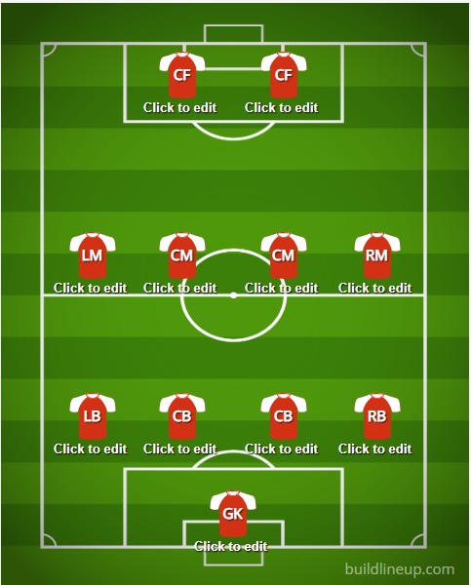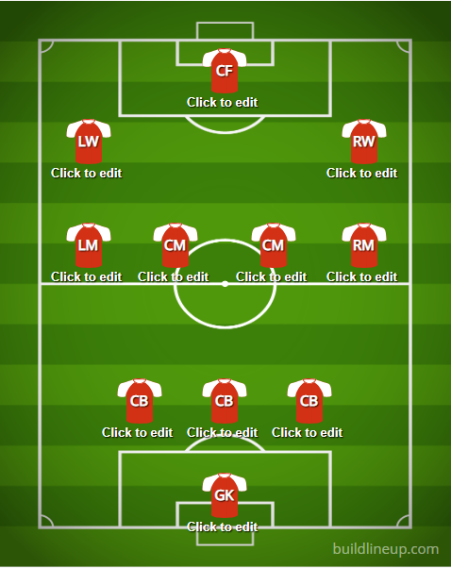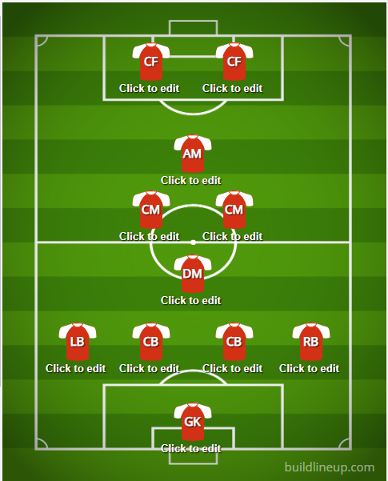

Figure one figure 2 figure 3

This is something I really need to look into I have a few ideas to help me overcome this obstacle.